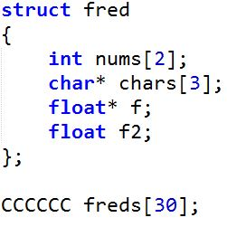

int = 4 bytes

char = 1 byte

float = 16 bytes

pointer = 8 bytes

Using the structure definition and the values above:

1. If I were declaring an array, like above, what would replace ‘CCCCCC’?
2. Give the size of the array being created. If there is not enough information, state this.
3. Identify the following algorithm:

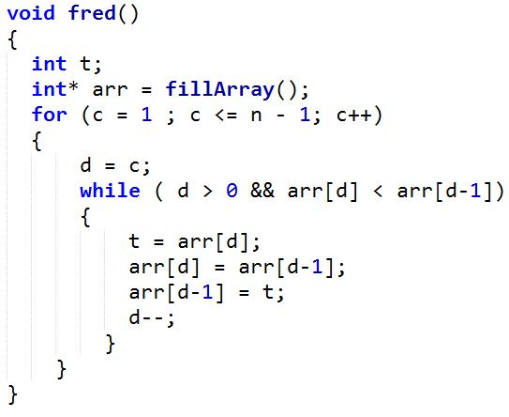

State what replaces the given set of letters in the following code to create the desired result:

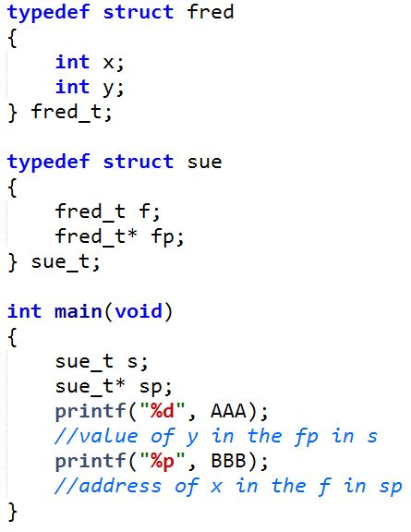

Note: The comment refers to the line above it.

1. AAA
2. BBB

True or False:

1. Since arrays are contiguous in memory, they take up less space than linked lists.
2. Quicksort is more efficient than insertion sort, but takes up more space because it has to create new temporary arrays to refer to.
3. A nested for loop automatically makes an algorithm O(n^2)
4. Arrays need to be freed explicitly, just like malloced memory

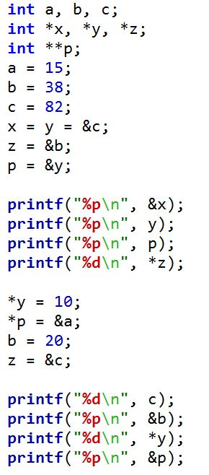

Address of…

A: 3200

B: 3800

C: 2900

X: 1320

Y: 1340

Z: 1200

P: 3000

Give the output of each print statement above (if there is not enough information, state this):

1. &x
2. y
3. p
4. \*zW
5. c
6. &b
7. \*y
8. &p

Use the given code to answer the next set of questions:

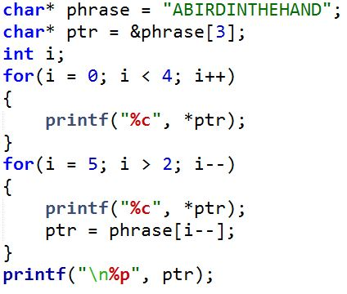

Address of the string: 4400

Address of ‘phrase’: 3000

Address of ‘ptr’: 2000

Size of char: 2 bytes

Size of int: 4 bytes

Size of pointer: 8 bytes

1. Give the output of the first for loop in this code. If there is not enough information, state this.
2. Give the output of the second for loop in this code. If there is not enough information, state this.
3. Give the output of the final print statement. If there is not enough information, state this.
4. What is the size of the memory pointed to by phrase? If there is not enough information, state this.

Use the following definition:

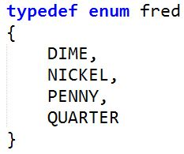

1. What is the result of DIME\*2 + PENNY\*3 + QUARTER\*4? If there is not enough information, state this.
2. There is a compile error. Find it.

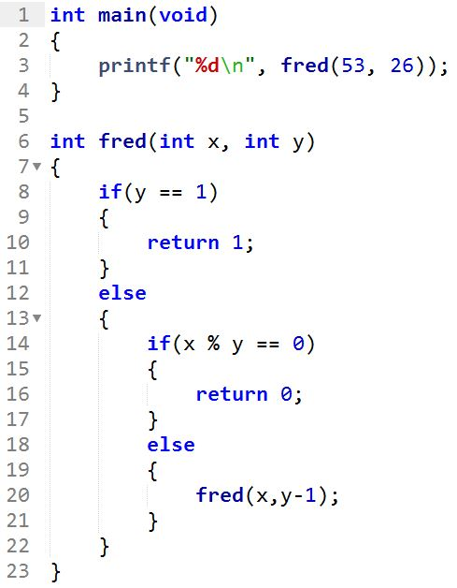

1. Line 20 demonstrates a certain technique. What is it?
2. How many times is fred called in this program?
3. What does the statement on line 3 print out?
4. What does this code do? (This question is really hard. Give it some thought)

Give the big O for the following scenarios:

1. Seeing how long it takes a car to drive 60 miles at 25 miles/hour
2. Getting a list of everyone’s name in the room
3. Counting the number of handshakes it takes for each person in a room to shake each other person in the room.
4. Finding the end of many sequential forks in the road.
5. Enqueuing
6. Inorder traversal
7. Getting the nth value in an array
8. Selection sort